Group 1 member:

1. Choi Hei Man 56237944
2. Lin Ka Ching 56235662
3. Lau Chi Man 56237747
4. Kwok Ka Hei 56237981

Building material company (Supplier) service blueprint

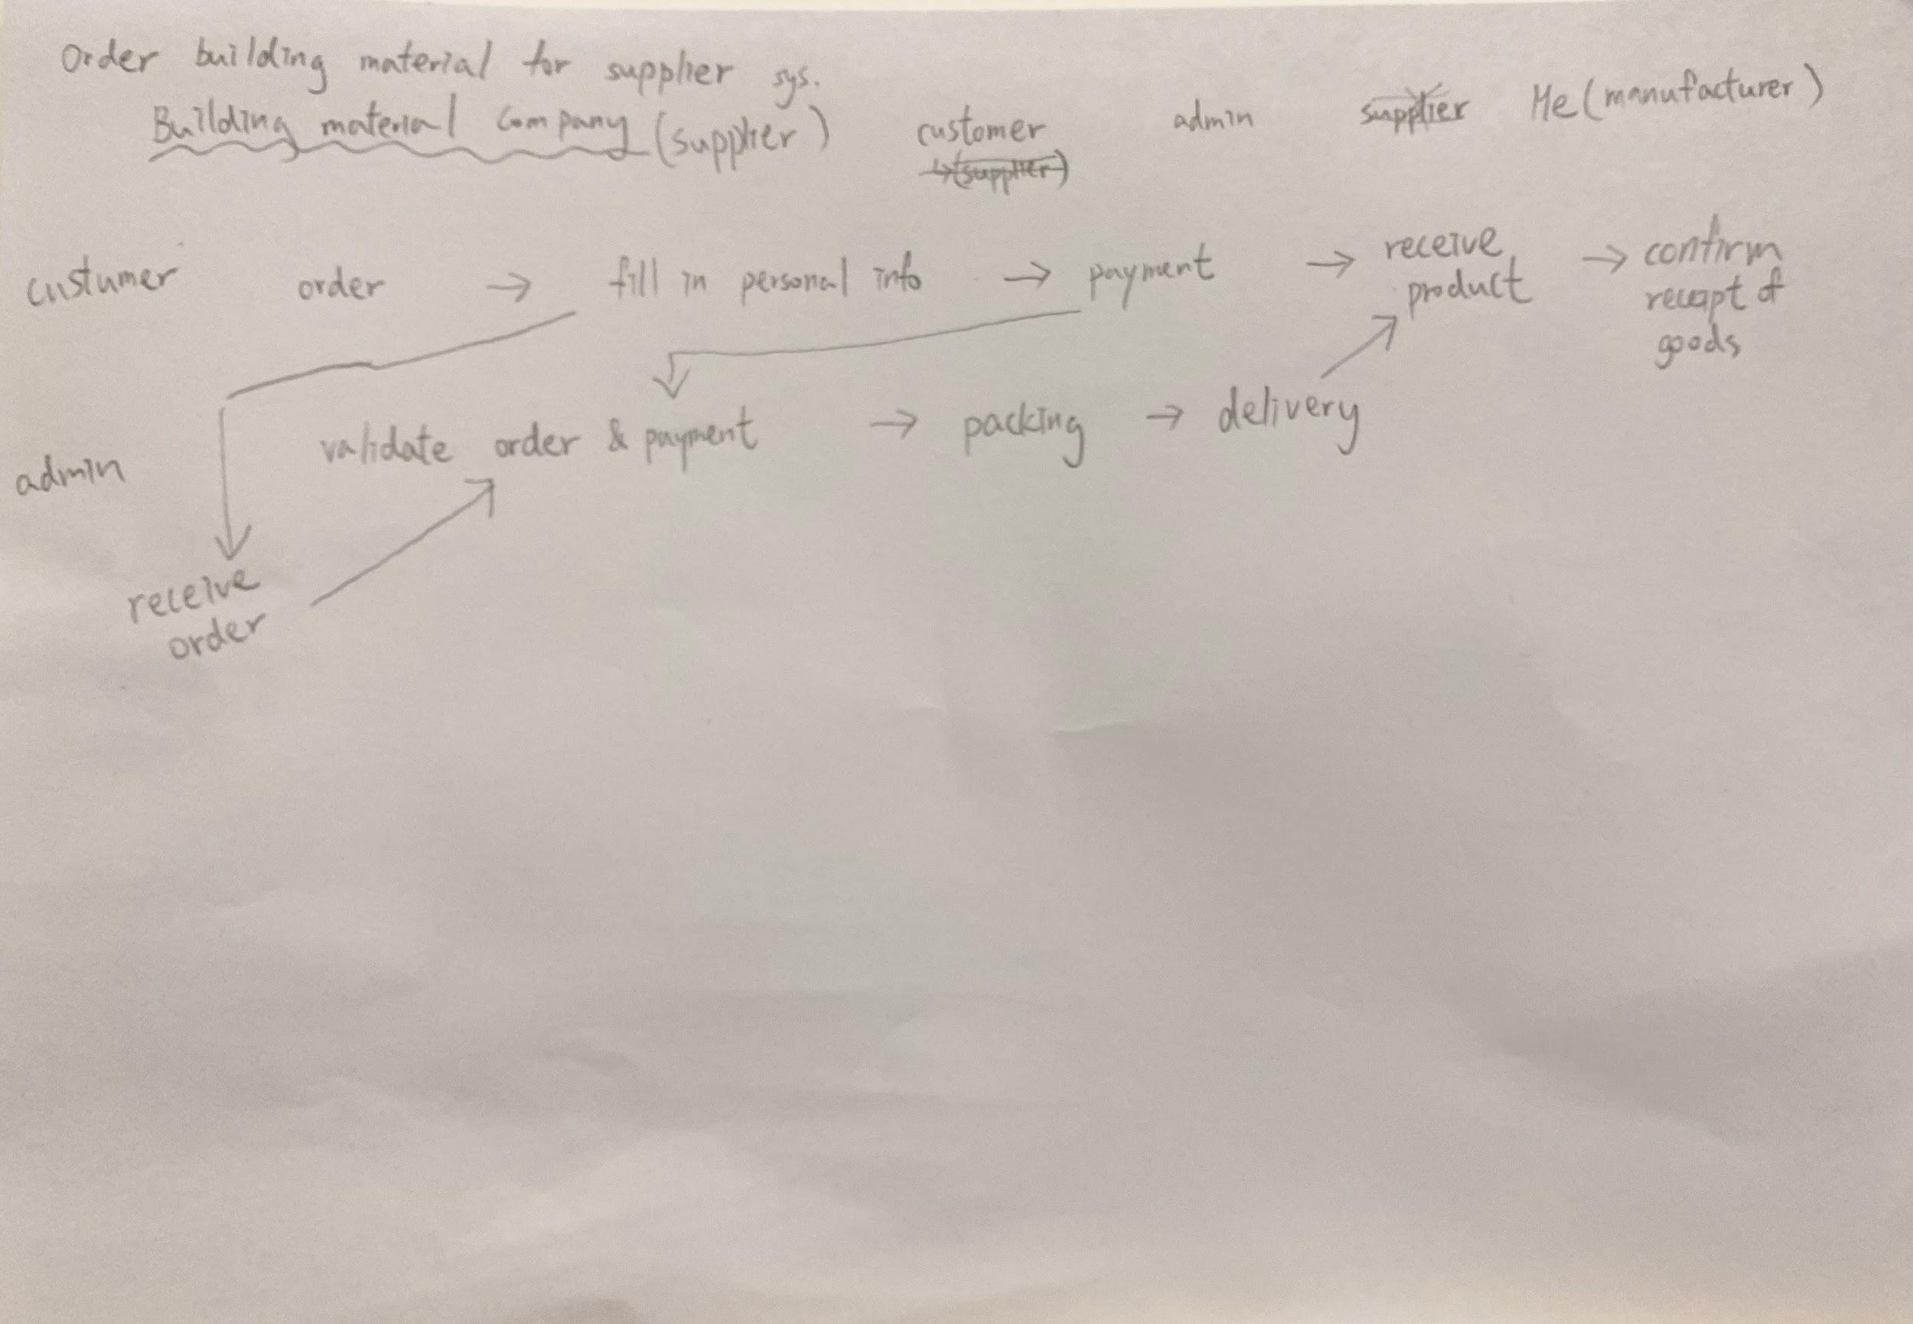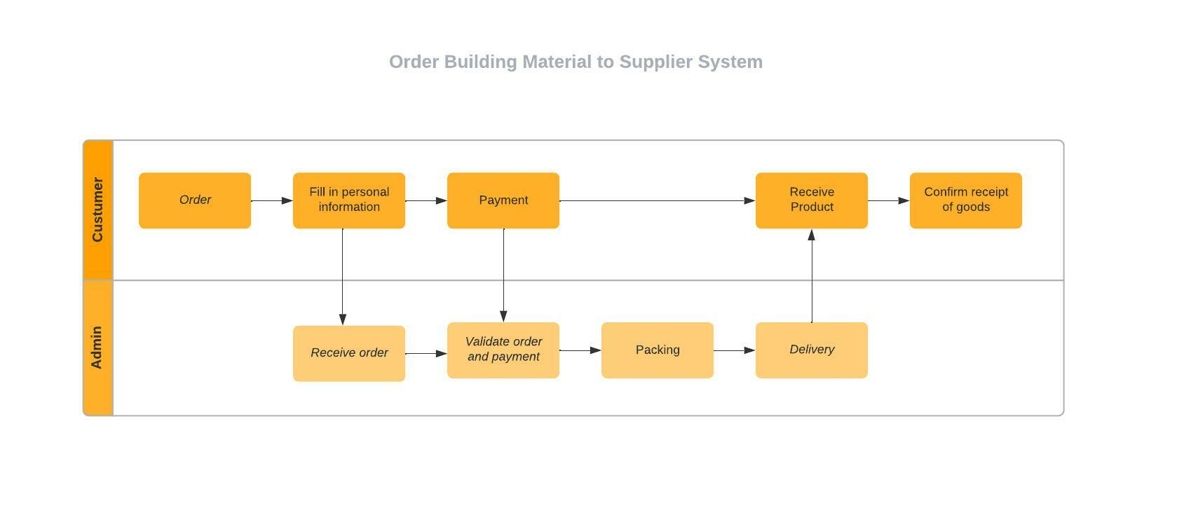

Design & decoration intermediary company service blueprint

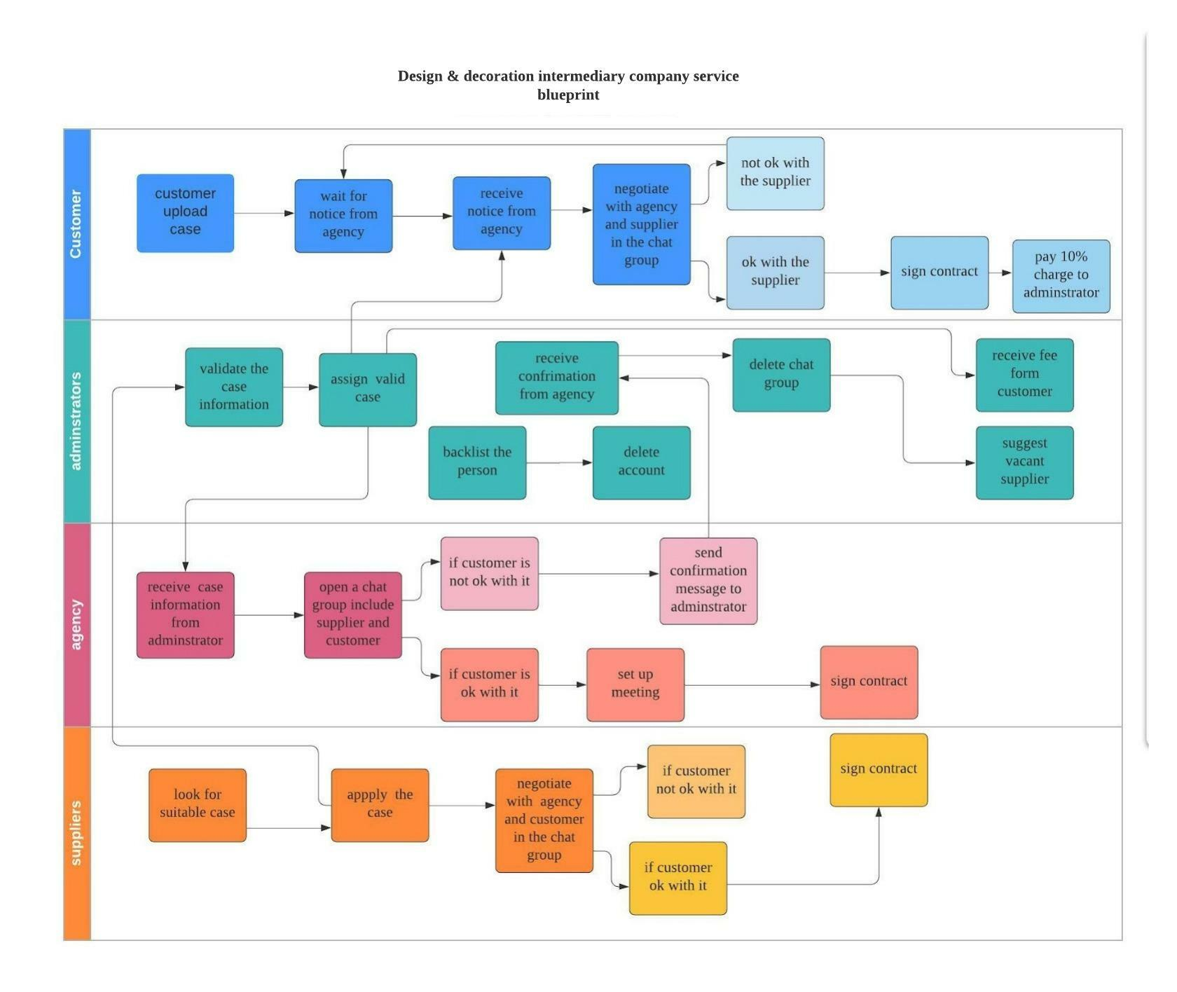

UML sequence diagram

